Ex:3

**AIM:**

**CODING:**

**package** javalab3;

**publicclass** javalab3

{

**int**rollno;

String name;

**void**insertRecord(**int**r, String n)

{

rollno=r;

name=n;

}

**void**displayInformation(){System.***out***.println(rollno+" "+name);

}

**publicstaticvoid** main(String args[])

{

javalab3 s1=**new** javalab3();

javalab3 s2=**new** javalab3();

s1.insertRecord(111,"Akash");

s2.insertRecord(222,"suresh");

s1.displayInformation();

s2.displayInformation();

}

}

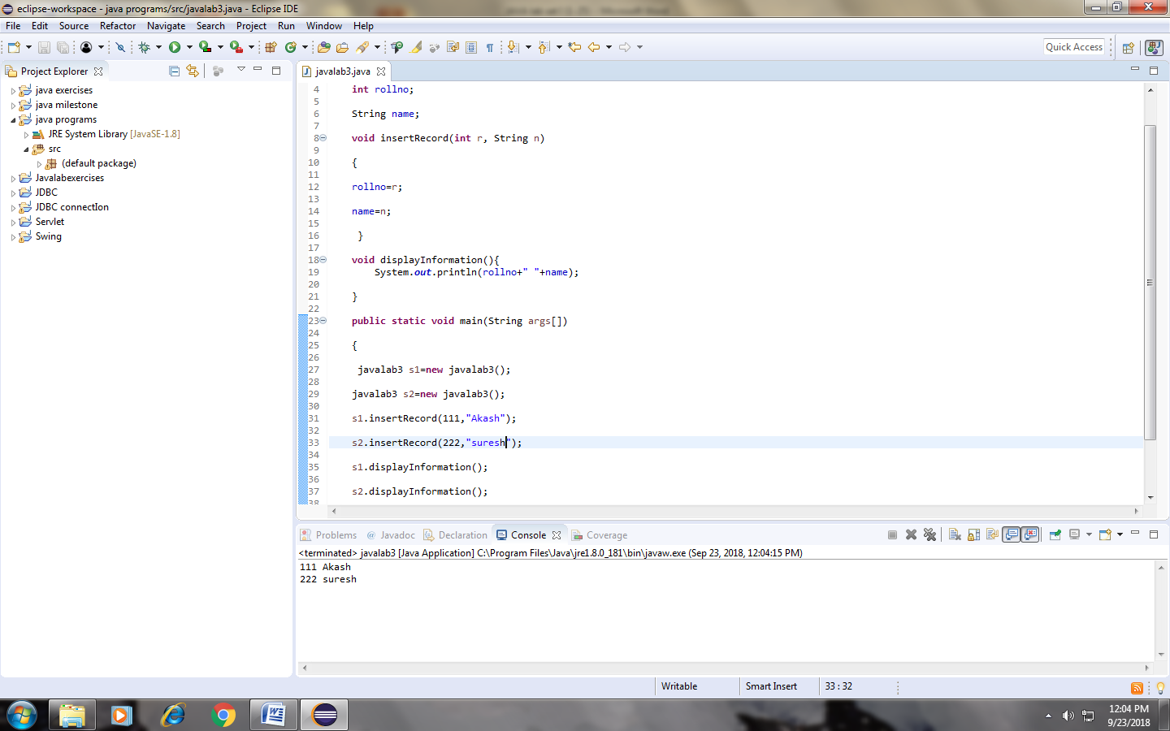

RESULT:

Ex:13

**AIM:**

**CODING:**

**package** javalab13;

**publicclass** javalab13 {

**int**id;

String name;

javalab13(**int**i,Stringn){

id = i;

name = n;

}

**void** display(){System.***out***.println(id+" "+name);}

**publicstaticvoid** main(String args[]){

javalab13 s1 = **new** javalab13(111,"Akash");

javalab13 s2 = **new** javalab13(222,"suresh");

s1.display();

s2.display();

}

}

Output:

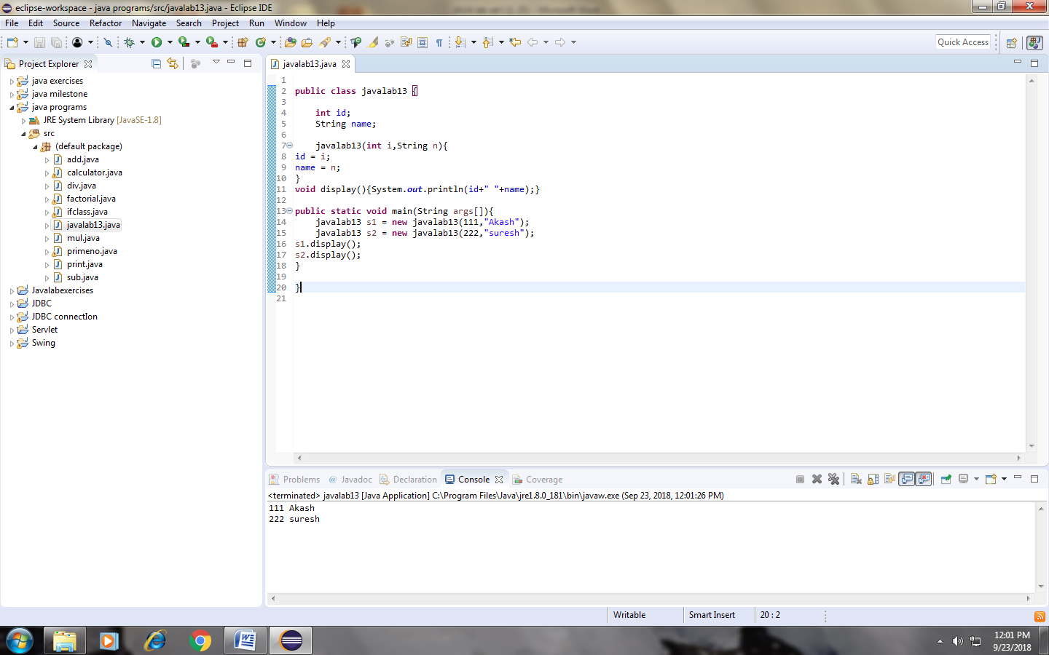RESULT:

Ex:14

**AIM:**

**CODING:**

**package** javalab14;

**publicclass** javalab14 {

**int**id;

String name;

**int**age;

javalab14(**int**i,Stringn){

id = i;

name = n;

}

javalab14(**int**i,Stringn,**int**a){

id = i;

name = n;

age=a;

}

**void** display(){System.***out***.println(id+" "+name+" "+age);}

**publicstaticvoid** main(String args[]){

javalab14 s1 = **new** javalab14(111,"Akash",19);

javalab14 s2 = **new** javalab14(222,"akhil",19);

s1.display();

s2.display();

}

}

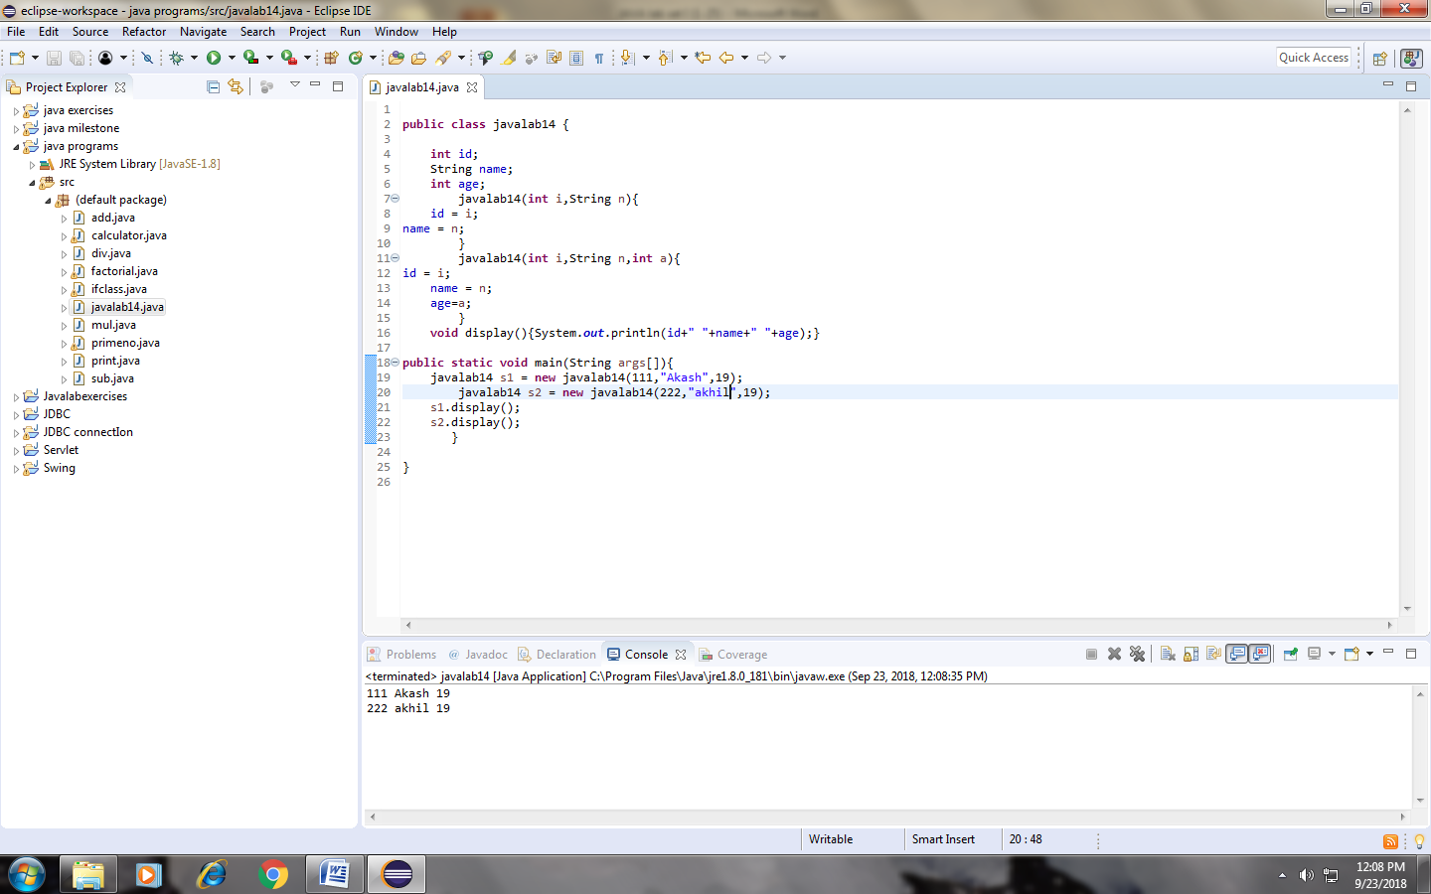RESULT:

Ex:15

**AIM:**

**CODING:**

**publicclass** javalab15 {

**int**id;

String name;

javalab15(**int**i,Stringn){

id = i;

name = n;

}

javalab15(javalab15 s){

id = s.id;

name =s.name;

}

**void** display(){System.***out***.println(id+" "+name);}

**publicstaticvoid** main(String args[]){

javalab15 s1 = **new** javalab15(111,"Akash");

javalab15 s2 = **new** javalab15(s1);

s1.display();

s2.display();

}

}

OUTPUT:

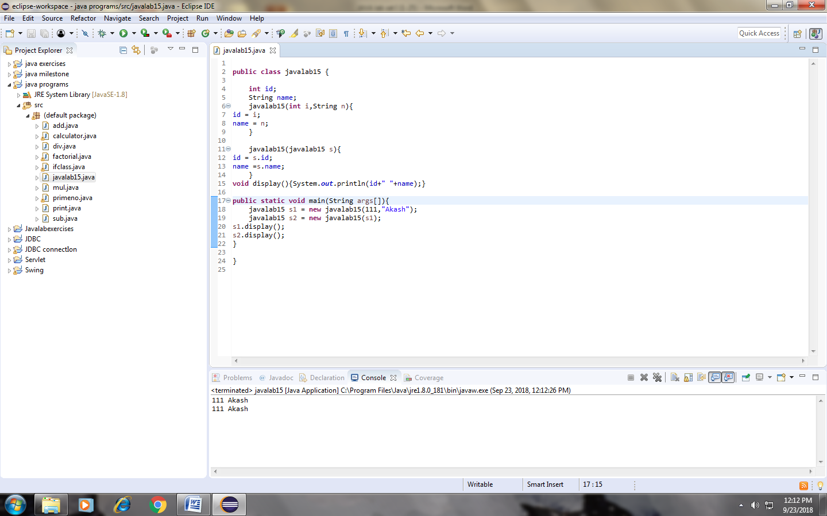RESULT:

Ex:18

**AIM:**

**CODING:**

**package** javalab18;

**publicclass** javalab18 {

**int**rollno;

String name;

**static** String *college* = "ITS";

**staticvoid** change(){

*college* = "RIT"; }

javalab18(**int**r, String n){

rollno = r;

name = n;

}

**void** display (){System.***out***.println(rollno+" "+name+" "+*college*);}

**publicstaticvoid** main(String args[]){

javalab18.*change*();

javalab18 s1 = **new** javalab18 (111,"akash");

javalab18 s2 = **new** javalab18 (222,"vinoth");

javalab18 s3 = **new** javalab18 (333,"akhil");

s1.display();

s2.display();

s3.display();

}

}

Output:

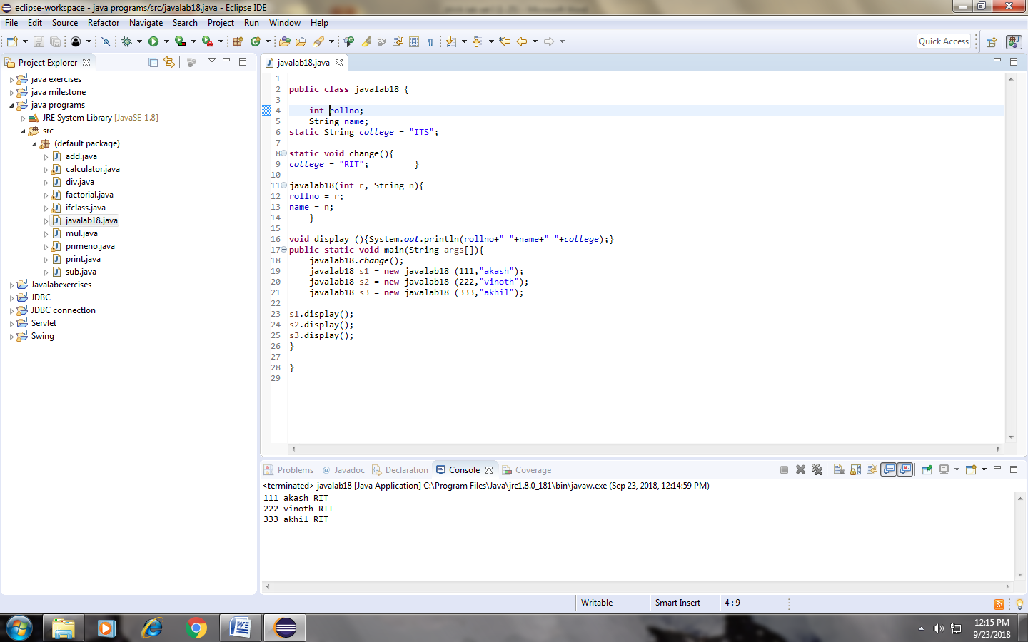

Ex:20

**AIM:**

**CODING:**

**package** javalab20;

**publicclass** javalab20 {

**int**id;

String name;

javalab20(){System.***out***.println("default constructor is invoked");}

javalab20(**int**id,Stringname){

**this** ();//it is used to invoked current class constructor.

**this**.id = id;

**this**.name = name;

}

**void** display(){System.***out***.println(id+" "+name);}

**publicstaticvoid** main(String args[]){

javalab20 e1 = **new** javalab20(111,"shiva");

javalab20 e2 = **new** javalab20(222,"akash");

e1.display();

e2.display();

}

}

Output:

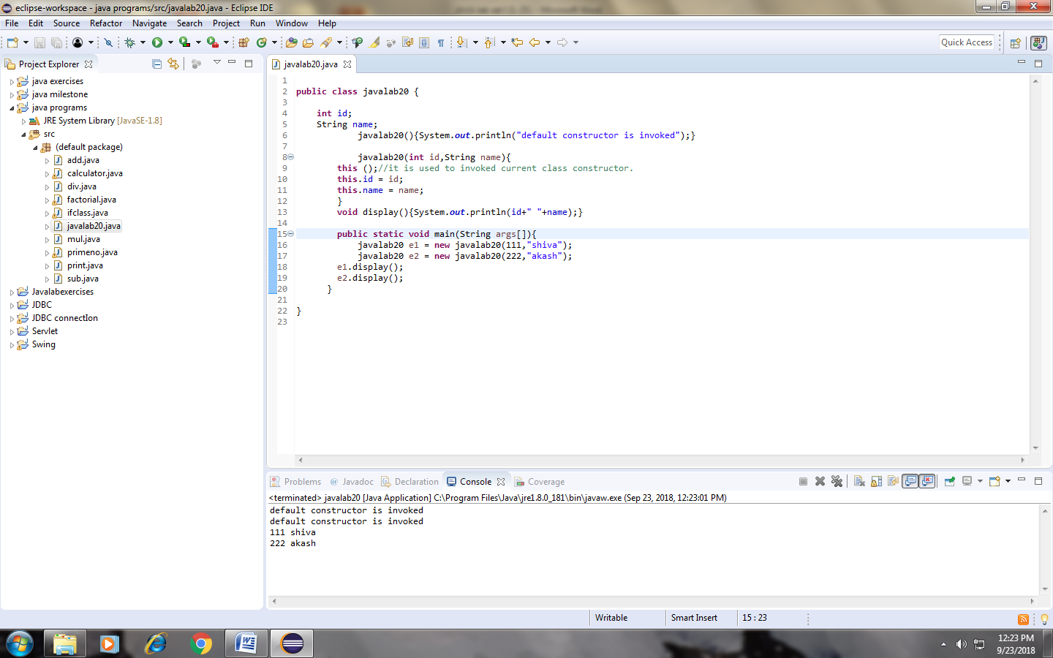RESULT:

Ex:21

**AIM:**

**CODING:**

**package** javalab21;

**publicclass** javalab21 {

**int**id;

String name;

String city;

javalab21(**int**id,Stringname){

**this**.id = id;

**this**.name = name;

}

javalab21(**int**id,Stringname,Stringcity){

**this**(id,name);//now no need to initialize id and name

**this**.city=city;

}

**void** display(){System.***out***.println(id+" "+name+" "+city);}

**publicstaticvoid** main(String args[]){

javalab21 e1 = **new** javalab21(111,"akash","maduravoyal");

javalab21 e2 = **new** javalab21(222,"priya","Avadi");

e1.display();

e2.display();

}

}

Output:

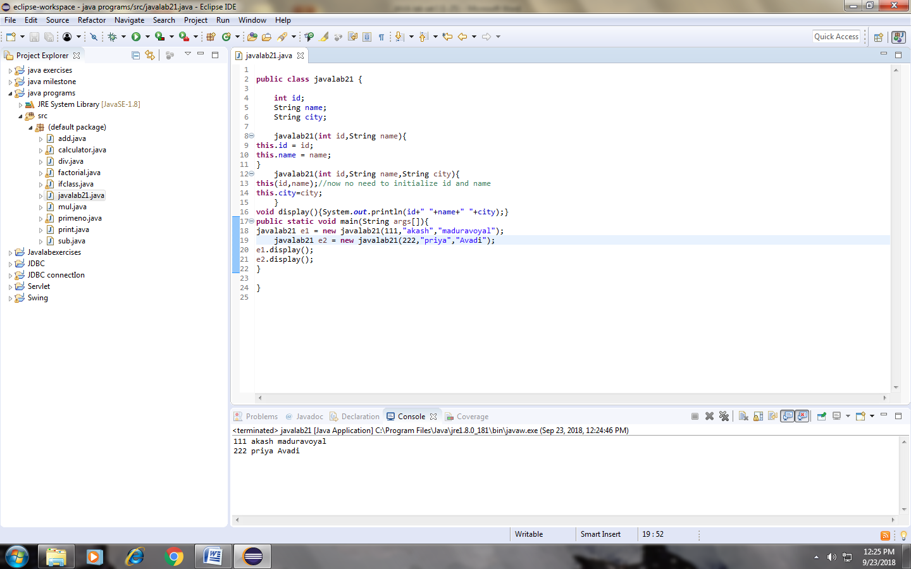RESULT: